|  |
| --- |
| Advanced Databases |
| CA1 Group Project |
| Section A (Data Mart) |

|  |
| --- |
| Cree Gunning, Lee Harold  3/6/2021 |

**Table of Contents**

1 Section A 2

1.1 Industry Topic and Business Area 2

# Section A

## Industry Topic and Business Area

**Industry Topic: Sports**

**Business Area: Purchase Orders (PO – Items)**

**1. Business Requirements**

***Processing Length (Days):***Helps business keep track of processing and shipping order times before sent out for delivery by calculating length of time between the order being placed and shipped for delivery. This lets the business have clear information on how long processing takes before it is on its route to the customer. Delays can be targeted and solved in order for faster shipping and processing times, which also helps delivery times.

***Delivery Length (Days):*** Going hand in hand with processing times, we will solve any delivery length problems as we keep track of the time between shipping and delivery by calculating the amount of days between them. By ironing out delivery length we could work towards a guarantee and build more trust and reliability with customers to purchase from our business again.

***Total Order Cost:***By adding the cost of the order and the optional priority shipping, we can keep track of the total cost of our orders for each customer. This allows us to easily see the total cost of each order and whether or not priority shipping was used, with priority being an additional €7.50 from January through October and an increased €10.00 during the Christmas period (November and December).

***Total Profit (excluding delivery):***By calculating the total cost of what we bought our items for and sold them for, we can calculate the profit made on each order not including delivery, allowing us to see our most profitable items and/or branches.

**2. Data Mart (Snowflake Schema)**

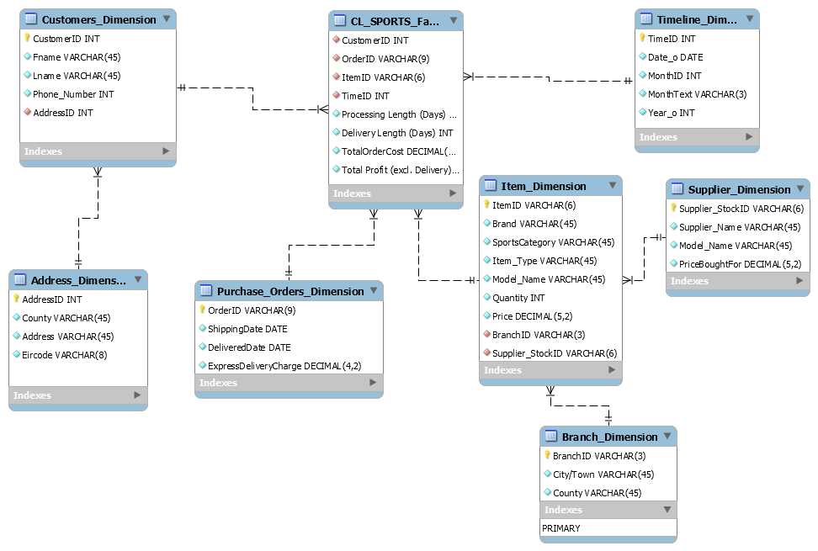

**3. SQL Script to create Fact table and Dimension tables**

-- -----------------------------------------------------

-- Schema cl_sports

-- -----------------------------------------------------

CREATE SCHEMA IF NOT EXISTS `cl_sports` DEFAULT CHARACTER SET utf8 ;

USE `cl_sports` ;

-- -----------------------------------------------------

-- Table `cl_sports`.`Timeline_Dimension`

-- -----------------------------------------------------

CREATE TABLE IF NOT EXISTS `cl_sports`.`Timeline_Dimension` (

`TimeID` INT NOT NULL,

`Date_o` DATE NOT NULL,

`MonthID` INT NOT NULL,

`MonthText` VARCHAR(3) NOT NULL,

`Year_o` INT NOT NULL,

PRIMARY KEY (`TimeID`))

-- -----------------------------------------------------

-- Table `cl_sports`.`Address_Dimension`

-- -----------------------------------------------------

CREATE TABLE IF NOT EXISTS `cl_sports`.`Address_Dimension` (

`AddressID` INT NOT NULL,

`County` VARCHAR(45) NOT NULL,

`Address` VARCHAR(45) NOT NULL,

`Eircode` VARCHAR(8) NOT NULL,

PRIMARY KEY (`AddressID`))

-- -----------------------------------------------------

-- Table `cl_sports`.`Customers_Dimension`

-- -----------------------------------------------------

CREATE TABLE IF NOT EXISTS `cl_sports`.`Customers_Dimension` (

`CustomerID` INT NOT NULL,

`Fname` VARCHAR(45) NOT NULL,

`Lname` VARCHAR(45) NOT NULL,

`Phone_Number` INT NOT NULL,

`AddressID` INT NOT NULL,

PRIMARY KEY (`CustomerID`),

INDEX `fk_Customers Dimension_Adress Dimension_idx` (`AddressID` ASC) VISIBLE,

CONSTRAINT `fk_Customers Dimension_Adress Dimension`

FOREIGN KEY (`AddressID`)

REFERENCES `cl_sports`.`Address_Dimension` (`AddressID`)

ON DELETE NO ACTION

ON UPDATE NO ACTION)

-- -----------------------------------------------------

-- Table `cl_sports`.`Branch_Dimension`

-- -----------------------------------------------------

CREATE TABLE IF NOT EXISTS `cl_sports`.`Branch_Dimension` (

`BranchID` VARCHAR(3) NOT NULL,

`City/Town` VARCHAR(45) NOT NULL,

`County` VARCHAR(45) NOT NULL,

PRIMARY KEY (`BranchID`))

-- -----------------------------------------------------

-- Table `cl_sports`.`Supplier_Dimension`

-- -----------------------------------------------------

CREATE TABLE IF NOT EXISTS `cl_sports`.`Supplier_Dimension` (

`Supplier_StockID` VARCHAR(6) NOT NULL,

`Supplier_Name` VARCHAR(45) NOT NULL,

`Model_Name` VARCHAR(45) NOT NULL,

`PriceBoughtFor` DECIMAL(5,2) NOT NULL,

PRIMARY KEY (`Supplier_StockID`))

-- -----------------------------------------------------

-- Table `cl_sports`.`Item_Dimension`

-- -----------------------------------------------------

CREATE TABLE IF NOT EXISTS `cl_sports`.`Item_Dimension` (

`ItemID` VARCHAR(6) NOT NULL,

`Brand` VARCHAR(45) NOT NULL,

`SportsCategory` VARCHAR(45) NOT NULL,

`Item_Type` VARCHAR(45) NOT NULL,

`Model_Name` VARCHAR(45) NOT NULL,

`Quantity` INT NOT NULL,

`Price` DECIMAL(5,2) NOT NULL,

`BranchID` VARCHAR(3) NOT NULL,

`Supplier_StockID` VARCHAR(6) NOT NULL,

PRIMARY KEY (`ItemID`),

INDEX `fk_Item Dimension_Branch Dimensional1_idx` (`BranchID` ASC) VISIBLE,

INDEX `fk_Item_Dimension_Supplier_Dimension1_idx` (`Supplier_StockID` ASC) VISIBLE,

CONSTRAINT `fk_Item Dimension_Branch Dimensional1`

FOREIGN KEY (`BranchID`)

REFERENCES `cl_sports`.`Branch_Dimension` (`BranchID`)

ON DELETE NO ACTION

ON UPDATE NO ACTION,

CONSTRAINT `fk_Item_Dimension_Supplier_Dimension1`

FOREIGN KEY (`Supplier_StockID`)

REFERENCES `cl_sports`.`Supplier_Dimension` (`Supplier_StockID`)

ON DELETE NO ACTION

ON UPDATE NO ACTION)

-- -----------------------------------------------------

-- Table `cl_sports`.`Purchase_Orders_Dimension`

-- -----------------------------------------------------

CREATE TABLE IF NOT EXISTS `cl_sports`.`Purchase_Orders_Dimension` (

`OrderID` VARCHAR(9) NOT NULL,

`ShippingDate` DATE NOT NULL,

`DeliveredDate` DATE NOT NULL,

`ExpressDeliveryCharge` DECIMAL(4,2) NOT NULL,

PRIMARY KEY (`OrderID`))

-- -----------------------------------------------------

-- Table `cl_sports`.`CL_SPORTS_Fact_Table`

-- -----------------------------------------------------

CREATE TABLE IF NOT EXISTS `cl_sports`.`CL_SPORTS_Fact_Table` (

`CustomerID` INT NOT NULL,

`OrderID` VARCHAR(9) NOT NULL,

`ItemID` VARCHAR(6) NOT NULL,

`TimeID` INT NOT NULL,

`Processing Length (Days)` INT NOT NULL,

`Delivery Length (Days)` INT NOT NULL,

`TotalOrderCost` DECIMAL(5,2) NOT NULL,

`Total Profit (excl. Delivery)` DECIMAL(5,2) NOT NULL,

INDEX `fk_Orders Fact Table_Customers Dimension1_idx` (`CustomerID` ASC) VISIBLE,

INDEX `fk_Orders Fact Table_Purchase Orders Dimension1_idx` (`OrderID` ASC) VISIBLE,

INDEX `fk_Orders Fact Table_Item Dimension1_idx` (`ItemID` ASC) VISIBLE,

INDEX `fk_Orders Fact Table_Timeline Dimension1_idx` (`TimeID` ASC) VISIBLE,

CONSTRAINT `fk_Orders Fact Table_Customers Dimension1`

FOREIGN KEY (`CustomerID`)

REFERENCES `cl_sports`.`Customers_Dimension` (`CustomerID`)

ON DELETE NO ACTION

ON UPDATE NO ACTION,

CONSTRAINT `fk_Orders Fact Table_Purchase Orders Dimension1`

FOREIGN KEY (`OrderID`)

REFERENCES `cl_sports`.`Purchase_Orders_Dimension` (`OrderID`)

ON DELETE NO ACTION

ON UPDATE NO ACTION,

CONSTRAINT `fk_Orders Fact Table_Item Dimension1`

FOREIGN KEY (`ItemID`)

REFERENCES `cl_sports`.`Item_Dimension` (`ItemID`)

ON DELETE NO ACTION

ON UPDATE NO ACTION,

CONSTRAINT `fk_Orders Fact Table_Timeline Dimension1`

FOREIGN KEY (`TimeID`)

REFERENCES `cl_sports`.`Timeline_Dimension` (`TimeID`)

ON DELETE NO ACTION

ON UPDATE NO ACTION)

**4. SQL script to load data into the Data Mart**

/*----------------------------------------------------------------------------

Insert data into `cl_sports`.`Timeline_Dimension` Table

------------------------------------------------------------------------------*/

INSERT INTO `cl_sports`.`Timeline_Dimension` VALUES (

"777701", "2019-01-15", 01, "JAN" , 2019

);

INSERT INTO `cl_sports`.`Timeline_Dimension` VALUES (

"777702", "2019-03-09", 03, "MAR" , 2019

);

INSERT INTO `cl_sports`.`Timeline_Dimension` VALUES (

"777703", "2019-05-27", 05, "MAY" , 2019

);

/*----------------------------------------------------------------------------

Insert data into `cl_sports`.`Address_Dimension` Table

------------------------------------------------------------------------------*/

INSERT INTO `cl_sports`.`Address_Dimension`VALUES (

"111111", "Dublin", "76 Hill Drive, Artane", "D05 GH21"

);

INSERT INTO `cl_sports`.`Address_Dimension`VALUES (

"111112", "Dublin", "92 Rune Drive, Coolock", "D06 RT72"

);

INSERT INTO `cl_sports`.`Address_Dimension`VALUES (

"111113", "Dublin", "14 Willow Drive, Santry", "D17 FC52"

);

/*----------------------------------------------------------------------------

Insert data into `cl_sports`.`Customers_Dimension` Table

------------------------------------------------------------------------------*/

INSERT INTO `cl_sports`.`Customers_Dimension` VALUES (

"000001", "Jessica", "McGeady", "0835551321", 111111

);

INSERT INTO `cl_sports`.`Customers_Dimension` VALUES (

"000002", "Kim", "McGowan", "0835340321", 111112

);

INSERT INTO `cl_sports`.`Customers_Dimension` VALUES (

"000003", "Wilfred", "Keely", "0893372102", 111113

);

/*----------------------------------------------------------------------------

Insert data into `cl_sports`.`Branch_Dimension` Table

------------------------------------------------------------------------------*/

INSERT INTO `cl_sports`.`Branch_Dimension` VALUES (

"D01", "Blanchardstown", "Dublin"

);

INSERT INTO `cl_sports`.`Branch_Dimension` VALUES (

"D02", "Raheny", "Dublin"

);

INSERT INTO `cl_sports`.`Branch_Dimension` VALUES (

"D03", "Ringsend", "Dublin"

);

/*----------------------------------------------------------------------------

Insert data into `cl_sports`.`Supplier_Dimension` Table

------------------------------------------------------------------------------*/

INSERT INTO `cl_sports`.`Supplier_Dimension` VALUES(

"RB1101", "Robinsons", "Adult X 20.2 Firm Ground", 80.00

);

INSERT INTO `cl_sports`.`Supplier_Dimension` VALUES(

"RB1102", "Robinsons", "Premier League 20/21 Strike Football", 5.00

);

INSERT INTO `cl_sports`.`Supplier_Dimension` VALUES(

"RB1103", "Robinsons", "Adults Mercurial Vapor 13 Academy Firm Ground", 15.00

);

/*----------------------------------------------------------------------------

Insert data into `cl_sports`.`Item_Dimension` Table

------------------------------------------------------------------------------*/

INSERT INTO `cl_sports`.`Item_Dimension` VALUES(

"CL1101", "Adidas", "Soccer", "Footwear", "Adult X 20.2 Firm Ground", 15, 130.00, "D02", "RB1101"

);

INSERT INTO `cl_sports`.`Item_Dimension` VALUES(

"CL1102", "Nike", "Soccer", "Training Range", "Premier League 20/21 Strike Football", 21, 28.00, "D01", "RB1102"

);

INSERT INTO `cl_sports`.`Item_Dimension` VALUES(

"CL1103", "Nike", "Soccer", "Footwear", "Adults Mercurial Vapor 13 Academy Firm Ground", 14, 50.00, "D03", "RB1103"

);

/*----------------------------------------------------------------------------

Insert data into `cl_sports`.`Purchase_Orders_Dimension` Table

------------------------------------------------------------------------------*/

INSERT INTO `cl_sports`.`Purchase_Orders_Dimension` VALUES (

"#73280601", "2019-01-17", "2019-01-20", 7.50

);

INSERT INTO `cl_sports`.`Purchase_Orders_Dimension` VALUES (

"#87493202", "2019-03-11", "2019-03-14", 7.50

);

INSERT INTO `cl_sports`.`Purchase_Orders_Dimension` VALUES (

"#33281030", "2019-05-30", "2019-06-04", 00.00

);

/*----------------------------------------------------------------------------

Insert data into `cl_sports`.`CL_SPORTS_Fact_Table` Table

------------------------------------------------------------------------------*/

INSERT INTO `cl_sports`.`CL_SPORTS_Fact_Table` VALUES (

"000001", "#73280601", "CL1108" ,"777701", 2, 3, 47.50, 35.50

);

INSERT INTO `cl_sports`.`CL_SPORTS_Fact_Table` VALUES (

"000002", "#87493202", "CL1107", "777702", 2, 3, 57.50, 35.00

);

INSERT INTO `cl_sports`.`CL_SPORTS_Fact_Table` VALUES (

"000003", "#33281030", "CL1102", "777703", 3, 5, 28.00, 23.00

);

**5. Queries and Outputs**

***Processing Length (Days):*** Used for calculating time between the order being placed and being shipped for delivery in order to troubleshoot any processing delays. Processing times are consistent during the year, with longer processing taking place during the Christmas period due to high demand, an issue we can possibly address.

*SELECT Customers_Dimension.Fname, Customers_Dimension.Lname, CL_SPORTS_Fact_Table.OrderID, Timeline_Dimension.MonthText, DATEDIFF(Purchase_Orders_Dimension.ShippingDate, Timeline_Dimension.Date_o) AS "Processing Length (Days)"*

*FROM CL_SPORTS_Fact_Table*

*INNER JOIN Customers_Dimension ON CL_SPORTS_Fact_Table.CustomerID=Customers_Dimension.CustomerID*

*INNER JOIN Purchase_Orders_Dimension ON CL_SPORTS_Fact_Table.OrderID=Purchase_Orders_Dimension.OrderID*

*INNER JOIN Timeline_Dimension ON CL_SPORTS_Fact_Table.TimeID=Timeline_Dimension.TimeID*

*ORDER BY Timeline_Dimension.Year_o;*

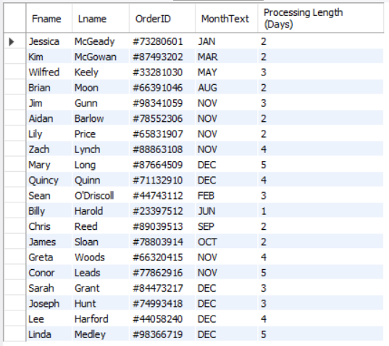

***Delivery Length (Days):*** Calculating time between shipping and delivery in order to keep track of delivery times all year round to notice any delays. Similar to processing length, delivery length is longer during the Christmas period as expected.

SELECT Customers_Dimension.Fname, Customers_Dimension.Lname, CL_SPORTS_Fact_Table.OrderID, Timeline_Dimension.MonthText, DATEDIFF(Purchase_Orders_Dimension.DeliveredDate, Purchase_Orders_Dimension.ShippingDate) AS "Delivery Length (Days)"

FROM CL_SPORTS_Fact_Table

INNER JOIN Customers_Dimension ON CL_SPORTS_Fact_Table.CustomerID=Customers_Dimension.CustomerID

INNER JOIN Purchase_Orders_Dimension ON CL_SPORTS_Fact_Table.OrderID=Purchase_Orders_Dimension.OrderID

INNER JOIN Timeline_Dimension ON CL_SPORTS_Fact_Table.TimeID=Timeline_Dimension.TimeID

ORDER BY Timeline_Dimension.Year_o;

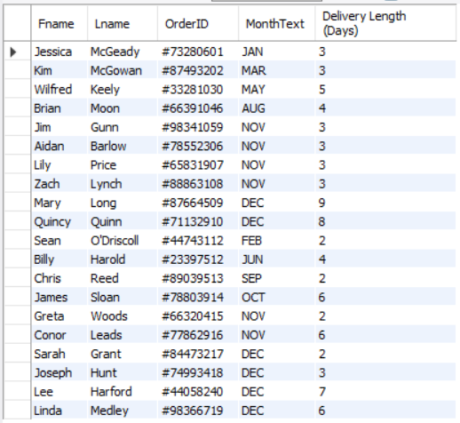

***Total Order Cost:*** Calculates total cost of order for customer including priority delivery (if used). As visible in the picture below, you can see the €10 priority charge taking place over the Christmas period due to demand.

SELECT CL_SPORTS_Fact_Table.OrderID, Purchase_Orders_Dimension.ExpressDeliveryCharge AS "Express Delivery Charge", Timeline_Dimension.MonthID, Purchase_Orders_Dimension.ExpressDeliveryCharge + Item_Dimension.Price AS "Total Cost of Order"

FROM CL_SPORTS_Fact_Table

INNER JOIN Purchase_Orders_Dimension ON CL_SPORTS_Fact_Table.OrderID=Purchase_Orders_Dimension.OrderID

INNER JOIN Item_Dimension ON CL_SPORTS_Fact_Table.ItemID=Item_Dimension.ItemID

INNER JOIN Timeline_Dimension ON CL_SPORTS_Fact_Table.TimeID=Timeline_Dimension.TimeID

ORDER BY Timeline_Dimension.Year_o;

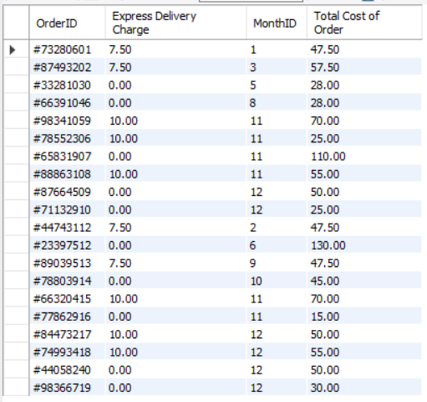

***Total Profit (excluding delivery):***Calculates profit on each order without delivery costs included. As seen below, branch one has been most profitable and popular which, as a business, allows us to allocate more staff and stock in order to provide adequate service for the high demand.

SELECT CL_SPORTS_Fact_Table.OrderID, Item_Dimension.BranchID, Supplier_Dimension.PriceBoughtFor AS "Bought For", Item_Dimension.Price AS "Sold For", Item_Dimension.Price - Supplier_Dimension.PriceBoughtFor AS "Total Profit of Order (excl. Delivery Charge)"

FROM CL_SPORTS_Fact_Table

INNER JOIN Item_Dimension ON CL_SPORTS_Fact_Table.ItemID=Item_Dimension.ItemID

INNER JOIN Supplier_Dimension ON Item_Dimension.Supplier_StockID=Supplier_Dimension.Supplier_StockID

ORDER BY BranchID;

